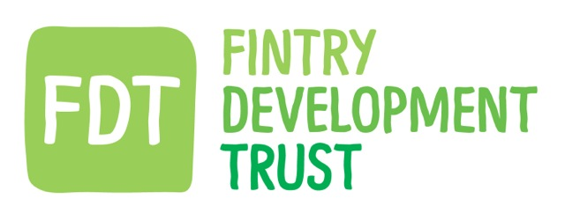

DATE: 15.11.18 LOCATION: HQ TIME: 7pm

DIRECTORS & STAFF | Present | Apologies
David Howell (Chair) | Y
Gordon Cowtan (Treasurer) | Y
Luke Emerton | Y
Hugh Edmond | Y
Iain Frazer | Y
Chris Robinson | Y
Anne Hislop | Y
Matthew Black (Community Project manager) | Y
Kayt Howell (Manager) | Y
Guest.

Agenda Item No. | Summary Discussion | Decision | Action.
1.Financial update | GC referenced the summary email sent to board prior to meeting.  A full annual budget will be prepared when current income figures are received from Falck. |  | GC KH
2. Dunmore Gardens | MB outlined the ongoing processes of the project - the due diligence aspects of the technical and financial aspects of the project. Although agreed that these processes are necessary, it is resulting in considerable delays in moving forward.  MB outlined the potential of a test borehole to clarify some of the technical issues.  MB has contacted the residents to provide as much of an update as possible, but the processes and responsibilities are in the hands of others. | The Board agreed that a timeline needs to be agreed and established with all project partners.  Long terms delays risk the project being cancelled for several reasons.  The Board asked MB to update with any relevant changes in progress. | MB
3.Balgair | MB outlined the situation re the maintenance contract and the options relating to that.  MB updated the board with the contact provided to Burness Paull.  MB reported on work done on thermostat issues. | MB to update Board on any progress re solicitors. | MB GC
4. Following Directors training | KH asked directors to update the Conflict of Interest register and will then update each year following the AGM.  KH is currently updating the Health and safety policy and will take the offer of free advice from DTAS. | The Board agreed the training provided by DTAS was very worthwhile. | Board KH
5.Waste | GC discussed the ideas of looking into the community’s response to waste reduction – how this meets FDT objectives and is part of the bigger conversations happening re plastic waste and climate change.  Meeting has been held with Zero Waste Scotland to investigate how we might engage the community. | Board agreed that this is a positive addition to our current energy focus.  The Board also agreed that although FDT would enable and guide the format, we do not currently have the capacity to fully support and this should be a community lead project instead. | GC AH KH
6.Biodiversity | GC opened a discussion re mapping the biodiversity of Fintry – possibly as a future project in conjunction with other groups in the village. | Board discussed the available existing formats which might be accessed and how those could be adapted for Fintry.  All agreed it’s something to continue in future discussions. | ALL
7.XR/ Greta Thunberg | The Board discussed ways in which FDT can further engage with the increasing focus by the public on environmental issues and climate change. As FDT’s remit is to create a zero waste, zero carbon and sustainable community - there is more we can do to inform and raise awareness. | The Board agreed that using our own newsletter communications, adding a ‘Green Page’ of info to the Focus publication and generally including current environmental issues within our communications with the community and via our social media platforms. | ALL
8.Appointed directors | The Board discussed the different slots available on our Board for appointed directors and the benefits of utilizing the positions with people with perhaps particular expertise and external views.  GC has had some discussions and information provided by others in the industry and discussed some of the potential candidates with the Board. | GC to further investigate options and potential candidates.  Board agreed that this would be beneficial to the Board. | GC Board.

Information to be minuted:

Objections to be recorded:

Date of Next Meeting: 29.05.19

