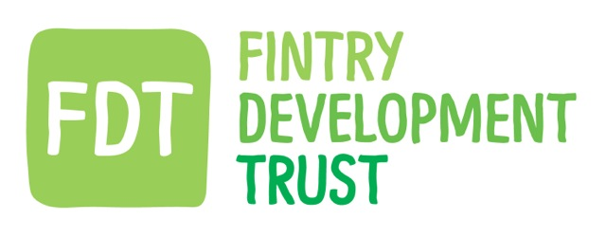

Fintry Development Trust - Environmental policy

FDT is committed to minimising the impact of its activities on the environment and will comply with all relevant environmental legislation.
The key aims and objectives of the Trust are to reduce carbon, support renewable energy and reduce waste and as such, take seriously our responsibilities in extending our environmental awareness to our working practises.
The key points of our Policy to achieve this are:
- integrate the consideration of environmental concerns and impacts into our decision making and activities.

- minimise our waste and then reuse or recycle as much of it as is possible.

- minimise energy and water use within our work place and processes in order to conserve supplies and minimise the consumption of natural resources.

- As far as is possible, purchase products and services that do the least damage to the environment. train, educate and inform our employees about environmental issues that may affect their work.

- promote environmental awareness among our employees and encourage them to work in an environmentally responsible manner.

- communicate our environmental commitment to clients, members and the public and encourage them to support it.

- where required by legislation or where significant health, safety or environmental hazards exist, develop and maintain appropriate emergency and spill response programmes,

Policy update record

DATE OF CHANGE | CHANGED BY | COMMENTS
29.10.20 | The Board | Initial agreement of policy implementation

