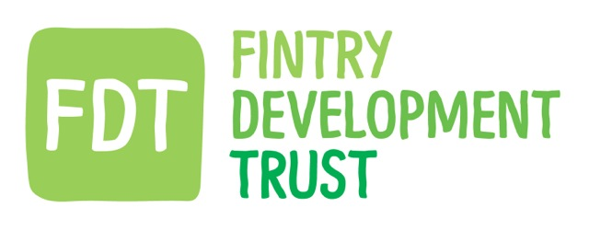
Registered in Scotland No. SC319146
Registered Office: C/O Fintry Sports & Recreation Club, Kippen Road, Fintry G63 0YA
Membership Application
Tick one of the below -
Full Membership (£1)
I apply for full lifetime membership of Fintry Development Trust. I agree with the aims of the trust (see attached information) and understand that should the company fail with insufficient funds to cover its liabilities, I may be liable for a payment of a maximum of £1. I am over 17 years old and live in the area covered by Fintry Community Council. I enclose the membership fee of £1.

Junior Membership (12 – 17 years old, no membership fee)
I apply for junior membership of Fintry Development Trust for three years. I agree with the aims of the trust (see attached information). I am between 12 and 17 years old and live in the area covered by Fintry Community Council.

Full name:

…………………………………………………………………………

Address:

Tel:

Email:
…………………………………………………………………………………………………………………………………

Signed: Date:
…………………………………………………………………………………………………………………………………

Please tick to opt in for general communications from FDT. We will not spam you!

Please return to Kayt Howell, FDT Manager, by posting into the FDT box inside the Sports Centre.

Please note: Membership is not limited to one per household. If you need another membership form, you’re welcome to contact Kayt Howell kayt@fintrydt.org.uk 07872 056 755 or download one from the FDT web site www.fintrydt.org.uk or just photocopy this one.
Fintry Development Trust
FDT grew out of the original aspirations of Fintry Renewable Energy Enterprise (FREE). FREE was set up in 2003 with the aim of making Fintry a carbon neutral, sustainable community. With this in mind FREE looked to engage with a local windfarm that was being planned nearby. The result was the Trust has the right to the output of a 2.5 MW turbine that is part of the Earlsburn windfarm.
The electricity this turbine produces is sold to the grid and the income this produces is received by the Trust and used for energy saving projects in the village.
The Trust’s Aims as defined in the memorandum of association –
a) To advance environmental protection by promoting the adoption of measures to encourage the more efficient use of the world's resources, and in particular more efficient use of non-renewable energy sources so as (i) to minimise the proliferation of mines, wells and other extraction facilities which degrade the natural environment and (ii) to reduce greenhouse gas emissions and thus avoid the damage to the natural environment caused by global warming
b) To prevent and/or relieve poverty, and to relieve those in need by reason of age, ill-health, disability, financial hardship or other disadvantage, through providing them (either free of cost, or at reduced cost) with a range of energy conservation measures
c) To advance education in the fields of renewable energy, energy conservation, and similar areas
d) To promote the voluntary sector and the effectiveness and/or efficiency of charities, and in particular, through providing them (either free of cost, or at reduced cost) with a range of energy conservation measures.
And such that the activities in pursuance of the above objects shall be focussed on Fintry and the surrounding area, as defined by the Fintry Community Council boundaries.
For further information on the work of the Trust visit www.fintrydt.org.uk.
Getting involved -
As always we welcome any and all input, especially if you have thoughts or ideas for projects and/or endeavours. You can find information on our notice board in the Sports Club and fill in a comment slip and drop it in the FDT box, email us on info@fintrydt.org.uk, check us out on Facebook (search Fintry Development Trust and ‘like’), or follow on Twitter (FintryDT

