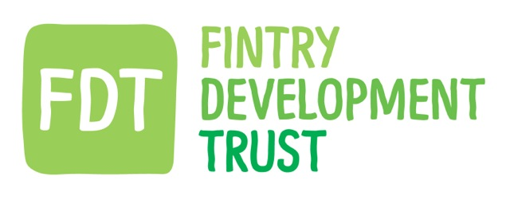

Fintry Development Trust’s Social Media Policy

PROCEDURES.

The following principles apply to professional use of social media on behalf of Fintry Development Trust (FDT) as well as personal use of social media when referencing FDT
• Employees need to know and adhere to FDT’s Company’s Code of Conduct, Employee Handbook, and other company policies when using social media in reference to FDT.
• Employees must be aware of the effect their actions may have on their images, as well as FDT’s image. The information that employees post or publish may be public information for a long time.
• Employees must be aware that FDT may observe content and information made available by employees through social media. Employees must use their best judgment in posting material that is neither inappropriate nor harmful to FDT, its employees, or customers.
• Although not an exclusive list, some specific examples of prohibited social media conduct include posting commentary, content, or images that are defamatory, pornographic, proprietary, harassing, libellous, or that can create a hostile work environment
• Employees are not to publish, post or release any information that is considered confidential or not public. If there are questions about what is considered confidential, employees must check with the Manager of a Board Director.
• Social media networks, blogs and other types of online content sometimes generate press and media attention or legal questions. Employees must refer these inquiries to authorized FDT spokespersons (Manager or Board Director)
• If employees find or encounter a situation while using social media that threatens to become antagonistic, employees should disengage from the dialogue in a polite manner and seek the advice of a supervisor.
• Employees must get appropriate permission before you refer to or post images of current or former employees, members, vendors or suppliers. Additionally, employees should get appropriate permission to use a third party's copyrights, copyrighted material, trademarks, service marks or other intellectual property.
• Social media use shouldn't interfere with employee’s responsibilities at FDT. FDT’s computer systems are to be used for business purposes only. When using FDT’s computer systems, use of social media for business purposes is allowed (ex: Facebook, Twitter, FDT blogs and LinkedIn), but personal use of social media networks or personal blogging of online content is discouraged and could result in disciplinary action.
• Subject to applicable law, after‐hours online activity that violates the Company’s Code of Conduct or any other company policy may subject an employee to disciplinary action or termination.
• If employees publish content after‐hours that involves work or subjects associated with FDT, a disclaimer must be used, such as this:
“The postings on this site are my own and may not represent FDT’s positions, strategies or opinions.”
• It is highly recommended that employees keep FDT related social media accounts separate from personal accounts, if practical.

Policy update record

DATE OF CHANGE | CHANGED BY | COMMENTS
24.11.20 | Board | Initial agreement of policy implementation

