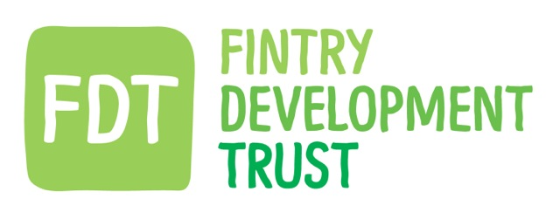

Minutes of Board meeting
22.02.23

Purpose of meeting to discuss and approve draft accounts for 21-22

PRESENT:
Via zoom - Anne Hislop (Chair of FDT), Gordon Cowtan (Consultant and Director of FREE & FCE),
In person - Kayt Howell (Manager),David Howell (Director of FDT & FREE), Chris Robinson (Director of FDT & FREE), Iain Frazer (Director of FDT & FCE), Iain MacKay (Director of FDT & FCE), Frances Hall (Director of FDT)
APOLOGIES: None

ACTIONS

1.The meeting was held prior to the financial planning meeting with Graham Finegold of Locality.

2. IF outlined the communications from our accountants and the measures recommended for attention.

3. Directors discussed the implications and asked questions regarding the accounts in general.

4. The Board agreed that FREE would donate £617,570 to FDT by 31 March but that the
N Power & Stirling Council grants should remain as deferred income on the FCE accounts.

5. The boards of all three companies also approved the accounts on the understanding that any changes necessary for the donation from FREE to FDT would be made.
KH to inform accountants of the decision.

6. The meeting then moved onto the financial planning with Graham Finegold.

