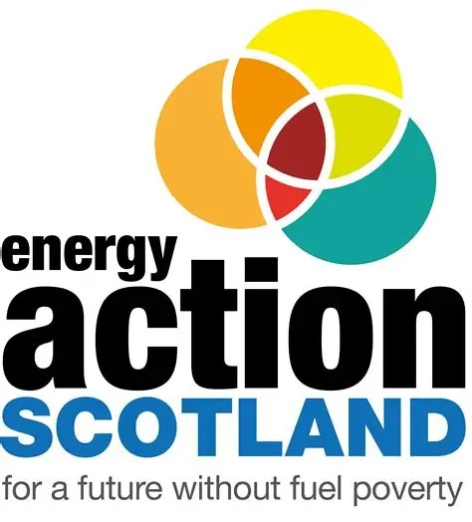
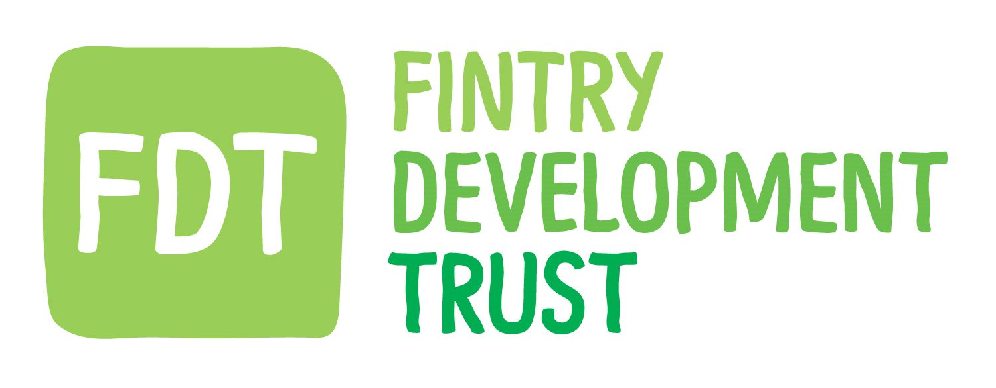
FINAL round of the Fuel Payment Grant
TO ACCESS THE GRANT, YOU MUST
APPLY IN FULL
(even if you have received the grant in past years, you MUST REAPPLY)

Request for Support Form 2025 – 2026
Important, please read:
As a result of the fuel crisis peak in 2022, Fintry Development Trust worked with Energy Action Scotland to provide a £500 payment to households that needed help the most in our community.
FDT funded this through the financial windfall we received at the time. This fourth round will be the last year our budget will support this grant. The grant was never intended to be provided for four years but FDT worked to make this possible.
Whether you are applying for the first time, or you have received this grant in previous years, YOU MUST REAPPLY FOR THIS FINAL ROUND OF FUNDING.
This ensures we have your up-to-date details and your consent for FDT to contact you about any future support we offer.
If you would prefer not to be contacted after this round, you may indicate this by opting out on the application form below.

The fund is administered by Energy Action Scotland on behalf of Fintry Development Trust
Energy Action Scotland c/o Wbg Services LLP, 168 Bath Street, Glasgow G2 4TP info@eas.org.uk
Energy Action Scotland Company limited by guarantee. Registered in Scotland No. 101660. Charity No. SCO 09280.

Request Form Notes

Introduction
If you apply through this ‘Request Form’, it is your responsibility to answers the questions honestly and to the best of your ability/knowledge. You may be required to provide evidence to support your application.

This may include copies of bank statements, copies of letters confirming benefits or similar.

It is not intended to provide direct payments to personal bank accounts as it is intended that payments will be made directly to energy suppliers or provided in the form of vouchers which can only be redeemed with an energy supplier.

However, there may be circumstances where a personal payment is the best method, and you may be asked to provide bank details.

If we make an award, we will keep the evidence you supplied and the details you provided to support your request for two years. If you are unsuccessful your data will be deleted. We will not share your personal information with other parties, except those specified in this application, unless authorised by you to do so.

Form Note 1
Please provide any additional information that is relevant to your request. You may have people living in your household with a need for higher amounts of warmth. You may have an inefficient heating system or one that is broken. You may have a prepayment meter for your electricity.

Form Note 2
The fund intends to support households that are struggling with costs and are on lower-than-average incomes for the Stirling Council Area. It is important to understand what level of income is being received into the household from all adults, people over 18, living there as their main residence.

Form Note 3
People living in fuel poverty spend more than 10% of their disposable income, income after taking account of housing costs, on their energy. The fund is looking to support those struggling the most, living in more inefficient homes or where people living in the households have higher heating requirements.

Form Note 4
If you have any additional financial information that you feel is important, please share that with us. You may have additional energy needs for essential medical equipment, mobility aids etc which may be increasing your need for energy consumption and increasing your costs. You may be managing debt with an energy supplier or dealing with other debts. This will not exclude you from support.

Form Note 5
Funding to help with energy costs is not, in most circumstances, the best way to ensure that bills can be met. Energy Action Scotland and Fintry Development Trust believe that improvement to the fabric of homes, insulation, maintenance can improve comfort and reduce costs over a much longer period of time. A condition of funding in 2025/2026 is that those eligible and awarded funding are willing to be contacted by FDT in the future, should the Trust offer further relevant support. If you would prefer not to be contacted, you may indicate this by opting out on the application form below.
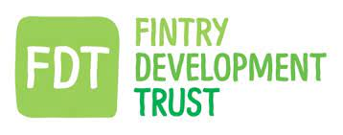
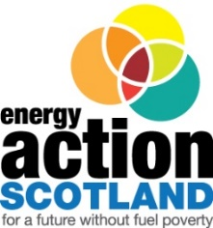

FINAL round of the Fuel Payment Grant
TO ACCESS THE GRANT, YOU MUST
APPLY IN FULL
(even if you have received the grant in past years, you MUST REAPPLY)
Request for Support Form 2025 - 2026
Our application form and conditions of award have changed from previous years. Please read and complete the form carefully.
In applying for and receiving help with your energy costs we are asking you for your consent for FDT to contact you about any future support we may offer. If you would prefer not to be contacted, you may indicate this by opting out on the application form below.
Applicant Details
Title
Forename
Surname
Date of Birth
Address

Postcode
Landline and/or Mobile No
Can we leave a message on voicemail?
Do you have an email address we can contact you on? | Yes / No  Please provide this:
What is your preferred method of contact? | Phone / Email / No preference
Alternative contact | Name of Contact
Alternative contact | Telephone no(s)
Are there children (under 16) living at the property | Yes / No |  |  |  | How many?
Any illness/condition amongst household | Yes / No
Please express why your household is in need of support? (see note 1)
Fuel Payments/Vouchers
Household annual income (combined income of all those in the property) (see note 2) |  |  |  | £
To the best of your knowledge are you likely to spend more than 10% of your disposable income on energy between April 2025 through to the end of March 2026? (see note 3) |  |  |  | Yes / No
How much are your energy costs per year?
Do you feel warm at home? |  |  | No Never / Occasionally / Often / Always
Are you in receipt of benefit(s)? See list |  |  | Yes / No
If not currently receiving benefits, are you awaiting confirmation of benefit? |  |  | Yes / No
Is there any additional financial information that you believe is important to your application? (see note 4)
Are you currently in debt with your supplier/s? |  |  | Yes / No
If yes, could you indicate which bracket you fall into? |  |  | Less than £500  Between 500 and £1,000  Between £1,000 and £1,500  More than £1,500
What is the tenure of your home? |  |  | Owner / Social Rented / Private Rented / Park Home

Type of Benefit | Tick
Personal Independence Payment / Scottish Adult Disability Payment
Attendance Allowance
Employment Support Allowance
State Pension
Disability Living Allowance / or other Disability Payment
Carers Allowance
Council Tax Reduction
Income Support
Housing Benefit
Working Tax Credits
Universal Credit
Pension Credit
Pension Age Winter Heating Payment
Child Winter Heating Assistance
Child Payment
Child Disability Payment

Any further information you feel is important for your application:
*I agree to share my information with Energy Action Scotland for the purpose of applying for support from the Fund and for the purpose of payments that I may receive or are made on my behalf.
*I understand the above information may be audited by Energy Action Scotland and other partners associated with the fund.

*I agree that by submitting this application, I am happy for my contact details to be passed to Fintry Development Trust to allow them to contact me about any relevant future support.
I prefer to opt OUT of providing my details to FDT
Please submit the completed form to: The box marked ALL GRANT APPLICATIONS in the Sports Club Foyer

