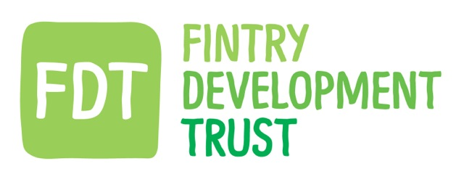

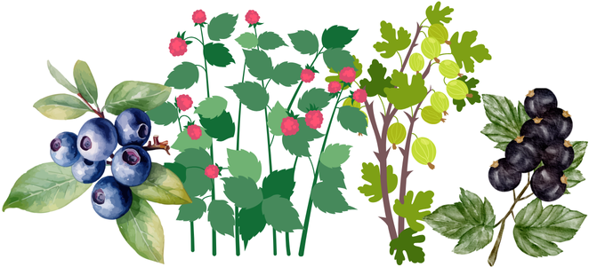

# FRUIT BUSH OFFER

# Introduction

After the great success of our recent tree offer, Fintry Development Trust are pleased to offer each Fintry homeowner, group or business, up to three native Scottish fruit bushes to plant within their own land and green spaces (these must be in the Fintry Community Council area).

The maximum number of fruit bushes which can be applied for is three.

The fruit bushes are well established and come in a 3-4 litre pot. You can choose from raspberry, blueberry, gooseberry and blackcurrant.

# Application Process

The offer is intended to be simple and straightforward to apply for. The application form is brief and can be completed either on paper to our post box or electronically to [admin@fintrydt.org.uk](mailto:admin@fintrydt.org.uk). The application form is attached.

**Note – your application needs to be received by 13th October 2025, to be included in the order and allow fruit bushes to be planted at the correct time of year**.

The steps to apply are:

1. You fill in the application form, either on paper or electronically, selecting how many bushes you would like and tick which species.
2. We suggest you google the species types to see which work best for you.
3. Within a week, we will tell you that your application has been received and give you an application number.
4. We will get back to you soon after to confirm the order has gone ahead and when your bushes will be due for collection from FDT.
5. Once you have received the bushes, please plant as soon as possible following the instructions given.
6. To apply on paper, please post it in the black box (marked FDT) under the FDT noticeboard in the Sports Club. To apply electronically, please email your completed form to [admin@fintrydt.org.uk](mailto:admin@fintrydt.org.uk)

If you have any questions, please email us at [admin@fintrydt.org.uk](mailto:admin@fintrydt.org.uk)

# Offer Conditions

1. Applications must reach us by **13th October 2025.**
2. Only one offer will be allocated per household, group or business (i.e. 3 fruit bushes max).
3. A maximum of three fruit bushes can be selected.
4. The applicant must own the land where the fruit bushes are to be planted or have permission to plant the fruit bushes.
5. While fruit bush choices will be considered, supply may be restricted, in which case we will provide a suitable alternative.
6. The awarding of this offer is ultimately at the discretion of the Board of FDT.
7. **Failure to comply with the above conditions may result in you being excluded from any future FDT grant schemes or offers.**
8. Everyone will be treated with dignity and respect at Fintry Development Trust. Bullying and harassment of any kind are in no-one's interest and will not be tolerated in the workplace; this includes bullying or harassment of staff by visitors or residents. **If bullying or harassment occurs, the person responsible will be excluded from applying for any further FDT offers or grants.**

**Application Form**

|  |
| --- |
| Name: |
| Address and postcode: |
| Email: |
| Phone: |

**Selection of Fruit Bush Species**

The following are the types of fruit bushes we aim to provide. Please research/google information on each type to be aware of the heights, spread, care and planting conditions of each, before making your selection. Further information on planting fruit bushes can be found at [Planting Fruit Bushes: The Complete Guide – Roots Plants](https://www.rootsplants.co.uk/blogs/features/planting-fruit-bushes)

**Please complete the table below with your choice of three fruit bushes:**

|  |  |  |  |
| --- | --- | --- | --- |
| **Name of Fruit Bush** | **Size** | **Please indicate which species you’d like** | **Please indicate how many you’d like** |
| Raspberry | 3 litre pot |  |  |
| Blueberry | 4 litre pot |  |  |
| Gooseberry | 3 litre pot |  |  |
| Blackcurrant | 3 litre pot |  |  |

**PLEASE CHECK THE FOLLOWING BEFORE YOU RETURN YOUR FORM:**

* **Have you selected up to three trees?**
* **Do you have permission to plant or are you the landowner of where the trees will be planted?**
* **Do you agree to undertake the planting as recommended.**
* **Have you carefully read all the offer conditions above and agree to abide by them?**

**Please note that failure to comply with the above conditions may exclude you from any future FDT grant schemes or offer.**

